Cell size and Cluster
Determine the number of Full-Duplex Channels available in a cluster and the total capacity of a cellular system where there are 10 clusters, each consisting of 20 cells with 18 channels in each.
Ans: Total number of Full-Duplex channel in cluster = 20 x 18 = 360
Link Budget Design
Evaluate the feasibility of a 5 km link, with one access point and one client radio. The access point is connected to an antenna with 10dBi gain, with a transmitting power of 20 dBm and a receive sensitivity of -89dBm. The client is connected to an antenna with 14dBi gain, with a transmitting power of 15dBm and a receive sensitivity of -82dBm. The cables in both systems are short, with a loss of 2dB at each side at the 2.4 GHz frequency of operation.
Solution:
The feasibility of a 5 km link has one access point and one client radio.
The access point is connected to an antenna with 10 dBi gain, with a transmitting power of 20 dBm and a receive sensitivity of -89 dBm.
The client is connected to an antenna with 14 dBi gain, with a transmitting power of 15 dBm and a r eceive sensitivity of -82 dBm.
The cables in both systems are short, with a loss of 2dB at each side at the 2.4 GHz frequency of operation.
Free space Path loss ($L_{f})=10\log_{10}\frac{λ^{2}}{{(4π)}^{2}d^{2}}=-114dB$
Path loss @ 5km link = $-114dB$
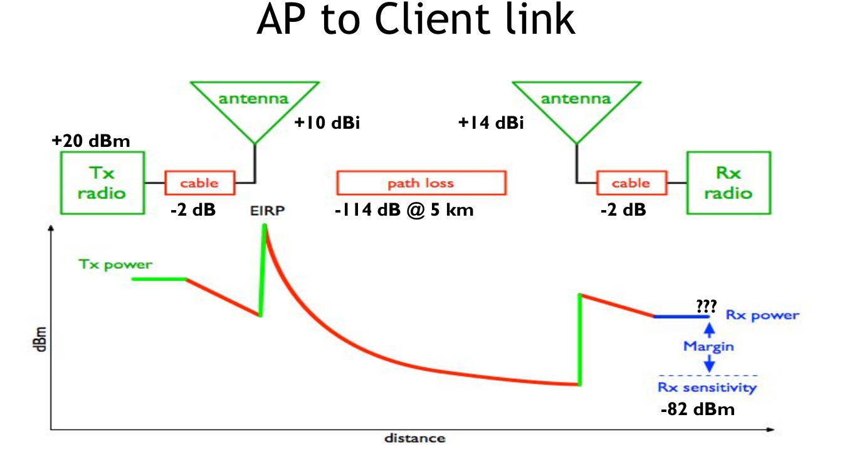
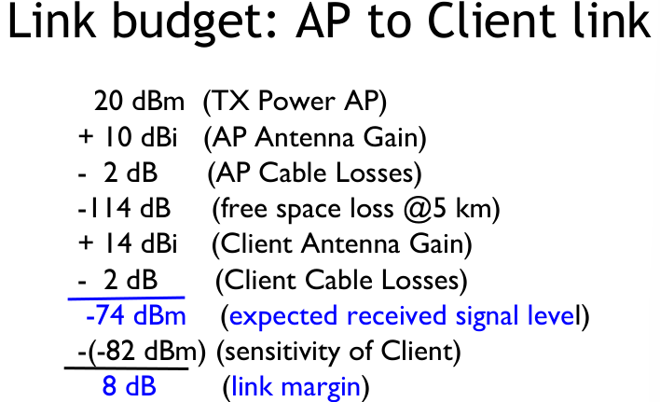

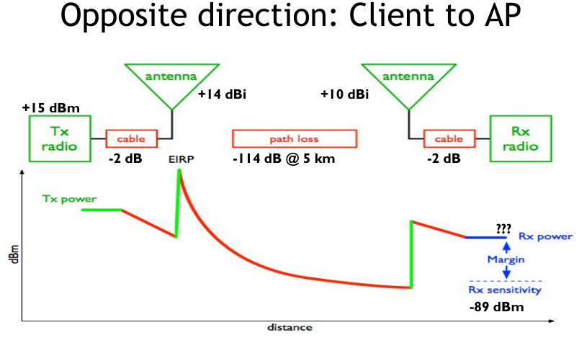
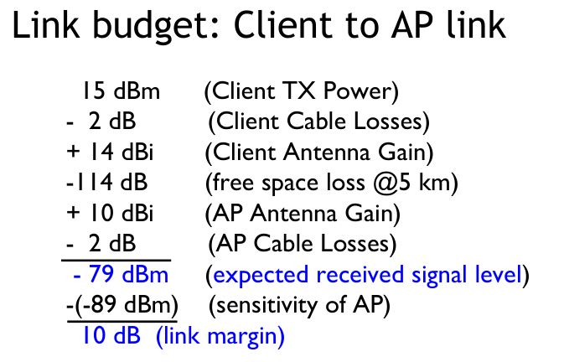

Modulation Techniques and Channel Decoding.
Write the waveforms to explain MSK transmission for a binary sequence 1010101.
Draw the waveforms to explain QPSK transmission for a binary sequence 1011001 modulated under QPSK techniques.
Why convolutional coding is memory coding, explain with an example where input stream is i = 10110….
Describe convolutional encoder with code dimension (2,1,3) and input message 10011 with generator polynomial $g_{1}\left(x\right)=x^{2}+x+1$ and $g_{2}\left(x\right)=x^{2}+1$. Also determine the final codeword.

For a given (6,3) linear block code, the generator matrix G is given as
G = $\left[\begin{matrix}1 & 0 & 0 \\ 0 & 1 & 0 \\ 0 & 0 & 1\end{matrix} \begin{matrix}1 & 0 & 1 \\ 0 & 1 & 1 \\ 1 & 1 & 0\end{matrix}\right]$
- All corresponding code vectors
- Minimum Hamming Distance
- Verify that code is a single error correcting code
- Parity check matrix
- Determine the transmitted codeword if received codeword is 100011
Find the linear block code encoder G if the generator polynomial g(x) = 1+$x^{2}+x^{3}$ for a (7,4) code.
Find the generator polynomial g(x) for a (7,4) cycle code and find the code vectors for the following data vectors:1010 and 1011
The generator polynomials for a 1/3 binary convolutional encoder is given by:
$$g_{1}\left(x\right)=x^{3}+x^{2}+1$$
$$g_{2}\left(x\right)=x^{3}+x^{2}$$
$$g_{3}\left(x\right)=x^{3}+1$$
Then calculate the encoded binary sequence for input sequence 011.
A spread spectrum communication system is characterized by the following parameters.
Duration of each information bit, $T_{b}=4.095ms$
Chip duration of a PN Sequence, $T_{c}=1μs$
Determine the processing gain and jamming margin if $\left({E_{b}}/{N_{0}}\right)$ =10 and the average probability of error $P_{e}=0.5 ×{10}^{-5}$.
Evaluate the feasibility of a 5 km link, with one access point and one client radio. The access point is connected to an antenna with 10dBi gain, with a transmitting power of 20 dBm and a receive sensitivity of -89dBm. The client is connected to an antenna with I4dBi gain, with a transmitting power of 15dBm and a receive sensitivity of -82dBm. The cables in both systems are short, with a loss of 2dB at each side at the 2.4 GHz frequency of operation.

